MODULES DESCRIPTION:
ADMINISTRATOR FUNCTION:
In this functionality the administrator will do his own responsibilities. Whenever he needs to change the Password, then he can directly change it.
- If any reason he needs to add a new user he can directly add.
- The admin user can view the details of all the users.
- He can view the details of all the employees of the company and any time he can add or remove any particular employee or employees.
- This application mainly concentrated about the transport. The admin user can view the details of all the categories of the transport. This categories viewing list has shows the ID Number of the category, how much amount per month, all these information will be provided.
- The admin user can view the details of all the vehicles details which are presently using in the particular company.
- In this list also each and every vehicle has its own identification number, registration number of the particular vehicle, and the type of the vehicle either it is own.
- The administrator can add the vehicle depends upon the situation of the company
USER FUNCTION:
In this Function, User could register to the software. He can see the listed vehicles available on the application with full description.
- He can book vehicle if he wishes to and also post his vehicle on rent by registering it on the application.
- After clicking on the vehicle name he gets the full information about the vehicle which he could use to make his decision according to his choice of vehicle and location of the vehicle.
- Admin has full access to the fleet management, bill management, daily reports, expenses, cancellations and refunds functionalities while other users could only access the transport functionality.
- Employees could additionally access expenses and daily reports sections while drivers could access fleet management and expenses functionalities of the application.
BOOKING FUNCTION:
In this function, the Transport user can enter into his functionality using his own User ID and Password.
- After entering into his functionality, whenever he needs to change his password then he can directly change it.
- The Admin can view the details of all the users and the employees of the company.
- The user can view the details of all the vehicles.
- The transport user can view the details of all the vehicle requests which are posted from the employees of the company.
- After his careful verification only he can provide the transport facility to the requested employee.
- He can add or remove the request of the employee.
FLEET MANAGEMENT FUNCTION:
This Function acts as the back bone of the Vehicle management system. It mainly has
- Service Logs
- Lubricant Logs
- Distance Logs
- Repair and Maintenance
- Parts changed records
- Vehicle Rating
- In Service Logs, Admin and Employee can View and Add the Service Interval details along with bill details to the system.
- In Lubricant Logs, Admin and Employee can View and Add the Lubricant consumption details along with bill details to the system.
- In Distance Logs, Admin and Employee can View and Add the Distance travelled by the vehicle and its fuel efficiency. It helps in determining the vehicle rating.
- Repair and Maintenance Logs keeps the track of Repair and Maintenance History and coming Schedules for all the vehicles and Parts Change Records keeps the track of changed parts of vehicles.
- Vehicle Rating are generated for all the listed vehicles on the basis of fuel efficiency, Aging and User Reviews

BILL MANAGEMENT FUNCTION:
This function is accessible only to admin and employees.
- It keeps the soft copy of all the expenses made by the company.
- Admin, Employees and Drivers can add soft copies of the bills while entering the expenses for proof while only admin has the privilege to see the soft copies at any time if he needs to.
It offers
  - View Bills
  - Search Bill
  - Print Bill

REPORT MANAGEMENT FUNCTION:
Reports Module keeps the tracks of different transactions made by the company.
- It enables user to save and print the required information generated by the software after analysis.
- Admin and Employee has the privilege to view Reports. It has Menu Options
- View Expenses
- View Fuel Logs
- View Repair & Maintenance Logs
- Reports are generated on daily basis hence View Reports by Date option is available in this module.

FEEDBACK MANAGEMENT FUNCTION:
Feedback Function has three main parts
- Give Feedback
- Check Feedback
- Rate a Vehicle
- In Give Feedback, Only a User can submit its feedback to the system.
- In Check Feedbacks, Admin and Employee both can check feedbacks submitted by the user along with user id, Date and Time of submission.
- In Rate a Vehicle, Admin and User both can rate a vehicle. This rating affects the overall Rating of the vehicle.

SYSTEM WORK FLOW ARCHITECTURE:
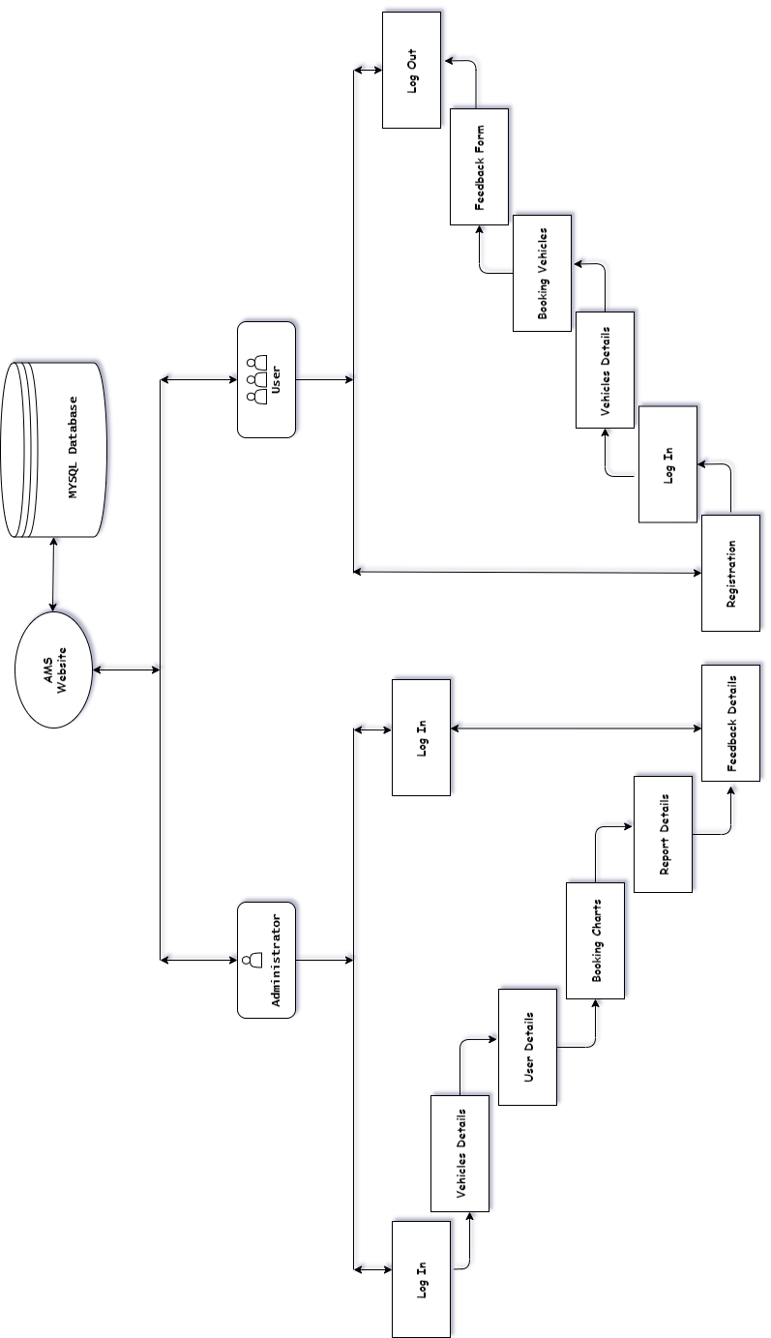

Class Diagram:
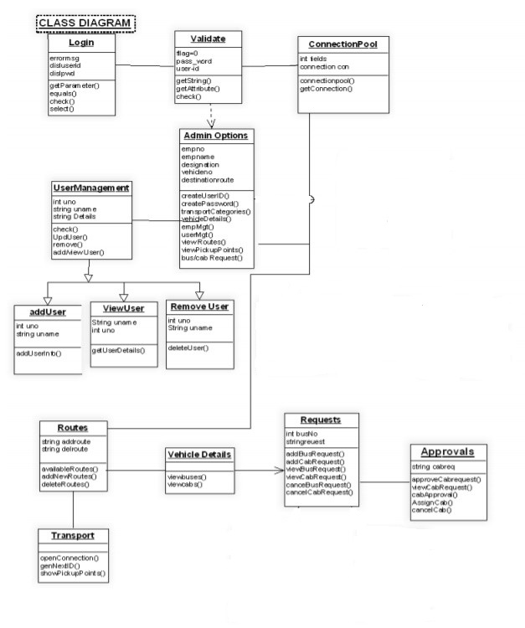
SOFTWARE DESCRIPTION:
MICROSOFT VISUAL STUDIO:
Microsoft Visual Studio is an integrated development environment (IDE) from Microsoft. It is used to develop computer programs, as well as websites, web apps, web services and mobile apps. Visual Studio uses Microsoft software development platforms such as Windows API, Windows Forms, Windows Presentation Foundation, Windows Store and Microsoft Silverlight. It can produce both native code and managed code. Visual Studio includes a code editor supporting IntelliSense (the code completion component) as well as code refactoring. The integrated debugger works both as a source-level debugger and a machine-level debugger. Other built-in tools include a code profiler, designer for building GUI applications, web designer, class designer, and database schema designer. It accepts plug-ins that expand the functionality at almost every level—including adding support for source control systems (like Subversion and Git) and adding new toolsets like editors and visual designers for domain-specific languages or toolsets for other aspects of the software development lifecycle (like the Azure DevOps client: Team Explorer).
Visual Studio supports 36 different programming languages and allows the code editor and debugger to support (to varying degrees) nearly any programming language, provided a language-specific service exists. Built-in languages include C, C++, C++/CLI, Visual Basic .NET, C#, F#, JavaScript, TypeScript, XML, XSLT, HTML, and CSS. Support for other languages such as Python, Ruby, Node.js, and M among others is available via plug-ins. Java (and J#) were supported in the past.
The most basic edition of Visual Studio, the Community edition, is available free of charge. The slogan for Visual Studio Community edition is "Free, fully-featured IDE for students, open-source and individual developers".
Visual Studio does not support any programming language, solution or tool intrinsically; instead, it allows the plugging of functionality coded as a VSPackage. When installed, the functionality is available as a Service. The IDE provides three services: SVsSolution, which provides the ability to enumerate projects and solutions; SVsUIShell, which provides windowing and UI functionality (including tabs, toolbars, and tool windows); and SVsShell, which deals with registration of VSPackages. In addition, the IDE is also responsible for coordinating and enabling communication between services. All editors, designers, project types and other tools are implemented as VSPackages. Visual Studio uses COM to access the VSPackages. The Visual Studio SDK also includes the Managed Package Framework (MPF), which is a set of managed wrappers around the COM-interfaces that allow the Packages to be written in any CLI compliant language.
Visual Studio does not include any source control support built in but it defines two alternative ways for source control systems to integrate with the IDE. A Source Control VSPackage can provide its own customised user interface. In contrast, a source control plugin using the MSSCCI (Microsoft Source Code Control Interface) provides a set of functions that are used to implement various source control functionality, with a standard Visual Studio user interface. MSSCCI was first used to integrate Visual SourceSafe with Visual Studio 6.0 but was later opened up via the Visual Studio SDK. Visual Studio .NET 2002 used MSSCCI 1.1, and Visual Studio .NET 2003 used MSSCCI 1.2. Visual Studio 2005, 2008, and 2010 use MSSCCI Version 1.3, which adds support for rename and delete propagation, as well as asynchronous opening.
Visual Studio supports running multiple instances of the environment (each with its own set of VSPackages). The instances use different registry hives (see MSDN's definition of the term "registry hive" in the sense used here) to store their configuration state and are differentiated by their AppId (Application ID). The instances are launched by an AppId-specific .exe that selects the AppId, sets the root hive, and launches the IDE. VSPackages registered for one AppId are integrated with other VSPackages for that AppId. The various product editions of Visual Studio are created using the different AppIds. The Visual Studio Express edition products are installed with their own AppIds, but the Standard, Professional, and Team Suite products share the same AppId. Consequently, one can install the Express editions side-by-side with other editions, unlike the other editions which update the same installation. The professional edition includes a superset of the VSPackages in the standard edition, and the team suite includes a superset of the VSPackages in both other editions. The AppId system is leveraged by the Visual Studio Shell in Visual Studio 2008.

NOTEPAD++:
Notepad++ is a text and source code editor for use with Microsoft Windows. It supports tabbed editing, which allows working with multiple open files in a single window. The project's name comes from the C increment operator.
Notepad++ is distributed as free software. At first the project was hosted on SourceForge.net, from where it has been downloaded over 28 million times, and twice won the SourceForge Community Choice Award for Best Developer Tool. The project was hosted on TuxFamily [fr] from 2010 to 2015; since 2015 Notepad++ has been hosted on GitHub. Notepad++ uses the Scintilla editor component.
Notepad++ was developed by Don Ho in September 2003. The developer used JEXT (a Java-based text editor) at his company but, dissatisfied with its poor performance, he began to develop a text editor written in C++ with Scintilla. He developed it in his spare time since the idea was rejected by his company. Notepad++ was built as a Microsoft Windows application; the author considered, but rejected, the idea of using wxWidgets to port it to the Mac OS X and Unix platforms.
Notepad++ was first released on SourceForge on 25 November 2003, as a Windows-only application. It is based on the Scintilla editor component, and is written in C++ with only Win32 API calls using only the STL to increase performance and reduce program size.
In January 2010 the US government obliged US-based open source project hosts to deny access from Cuba, Iran, North Korea, Sudan, and Syria to comply with U.S. law.
In 2011 Lifehacker described Notepad++ as "The Best Programming Text Editor for Windows", stating that "if you prefer a simple, lightweight, and extensible programming plain-text editor, our first choice is the free, open-source Notepad++".
In 2014 Lifehacker readers voted Notepad++ as the "Most Popular Text Editor", with 40% of the 16,294 respondents specifying it as their most-loved editor. The Lifehacker team summarized the program as being "fast, flexible, feature-packed, and completely free".
In 2015 Stack Overflow conducted a worldwide Developer Survey, and Notepad++ was voted as the most used text editor worldwide with 34.7% of the 26,086 respondents claiming to use it daily.
XAMPP:
XAMPP is a free and open-source cross-platform web server solution stack package developed by Apache Friends, consisting mainly of the Apache HTTP Server, MariaDB database, and interpreters for scripts written in the PHP and Perl programming languages. Since most actual web server deployments use the same components as XAMPP, it makes transitioning from a local test server to a live server possible.
XAMPP's ease of deployment means a WAMP or LAMP stack can be installed quickly and simply on an operating system by a developer, with the advantage that common add-in applications such as WordPress and Joomla! can also be installed with similar ease using Bitnami. XAMPP is regularly updated to the latest releases of Apache, MariaDB, PHP and Perl. It also comes with a number of other modules including OpenSSL, phpMyAdmin, MediaWiki, Joomla, WordPress andmore. Self-contained, multiple instances of XAMPP can exist on a single computer, and any given instance can be copied from one computer to another. XAMPP is offered in both a full and a standard version (Smaller version).
The web server solution stack installed in Personal PC or the development system faces common issues of having the common port numbers requested by XAMPP. Most commonly Skype or MySQL installed in PC have common conflict due to the same port number being requested by XAMPP. Although a port number conflict can be bypassed by stopping the applications using the same port, the better solution is to change the port number. The most common MySQL port can be found in my.ini, config.inc.php and php.ini files from XAMPP control panel.
The port number are 3306 for MySQL, 80 for Apache and 443 for SSL, the port numbers can be replaced with subsequent number like 3307 or 3308. Find the port numbers in respective files, for which port need to be changed, then replace with subsequent port number. The same port numbers should also be replaced in XAMPP Service and Port number settings.
Officially, XAMPP's designers intended it for use only as a development tool, to allow website designers and programmers to test their work on their own computers without any access to the Internet. To make this as easy as possible, many important security features are disabled by default. XAMPP has the ability to serve web pages on the World Wide Web. A special tool is provided to password-protect the most important parts of the package.
HTML:
Hypertext Markup Language (HTML) is the standard markup language for documents designed to be displayed in a web browser. It can be assisted by technologies such as Cascading Style Sheets (CSS) and scripting languages such as JavaScript.
Web browsers receive HTML documents from a web server or from local storage and render the documents into multimedia web pages. HTML describes the structure of a web page semantically and originally included cues for the appearance of the document.
HTML elements are the building blocks of HTML pages. With HTML constructs, images and other objects such as interactive forms may be embedded into the rendered page. HTML provides a means to create structured documents by denoting structural semantics for text such as headings, paragraphs, lists, links, quotes and other items. HTML elements are delineated by tags, written using angle brackets. Tags such as <img /> and <input /> directly introduce content into the page. Other tags such as <p> surround and provide information about document text and may include other tags as sub-elements. Browsers do not display the HTML tags, but use them to interpret the content of the page.
HTML can embed programs written in a scripting language such as JavaScript, which affects the behavior and content of web pages. Inclusion of CSS defines the look and layout of content. The World Wide Web Consortium (W3C), former maintainer of the HTML and current maintainer of the CSS standards, has encouraged the use of CSS over explicit presentational HTML since 1997.
HTML is a markup language that web browsers use to interpret and compose text, images, and other material into visual or audible web pages. Default characteristics for every item of HTML markup are defined in the browser, and these characteristics can be altered or enhanced by the web page designer's additional use of CSS. Many of the text elements are found in the 1988 ISO technical report TR 9537 Techniques for using SGML, which in turn covers the features of early text formatting languages such as that used by the RUNOFF command developed in the early 1960s for the CTSS operating system: these formatting commands were derived from the commands used by typesetters to manually format documents.

JAVASCRIPT:
JavaScript often abbreviated as JS, is a programming language that conforms to the ECMAScript specification. JavaScript is high-level, often just-in-time compiled, and multi-paradigm. It has curly-bracket syntax, dynamic typing, prototype-based object-orientation, and first-class functions.
Alongside HTML and CSS, JavaScript is one of the core technologies of the World Wide Web. JavaScript enables interactive web pages and is an essential part of web applications. The vast majority of websites use it for client-side page behavior, and all major web browsers have a dedicated JavaScript engine to execute it. As a multi-paradigm language, JavaScript supports event-driven, functional, and imperative programming styles. It has application programming interfaces (APIs) for working with text, dates, regular expressions, standard data structures, and the Document Object Model (DOM).
The ECMAScript standard does not include any input/output (I/O), such as networking, storage, or graphics facilities. In practice, the web browser or other runtime system provides JavaScript APIs for I/O.
JavaScript engines were originally used only in web browsers, but they are now core components of other runtime systems, such as Node.js and Deno. These systems are used to build servers and are also integrated into frameworks, such as Electron and Cordova, for creating a variety of applications.
Although there are similarities between JavaScript and Java, including language name, syntax, and respective standard libraries, the two languages are distinct and differ greatly in design.
The use of JavaScript has expanded beyond its web browser roots. JavaScript engines are now embedded in a variety of other software systems, both for server-side website deployments and non-browser applications.
Initial attempts at promoting server-side JavaScript usage were Netscape Enterprise Server and Microsoft's Internet Information Services, but they were small niches. Server-side usage eventually started to grow in the late-2000s, with the creation of Node.js and other approaches.

CSS (Cascading Style Sheets):
Cascading Style Sheets (CSS) is a style sheet language used for describing the presentation of a document written in a markup language such as HTML. CSS is a cornerstone technology of the World Wide Web, alongside HTML and JavaScript.
CSS is designed to enable the separation of presentation and content, including layout, colors, and fonts. This separation can improve content accessibility, provide more flexibility and control in the specification of presentation characteristics, enable multiple web pages to share formatting by specifying the relevant CSS in a separate .css file which reduces complexity and repetition in the structural content as well as enabling the .css file to be cached to improve the page load speed between the pages that share the file and its formatting.
Separation of formatting and content also makes it feasible to present the same markup page in different styles for different rendering methods, such as on-screen, in print, by voice (via speech-based browser or screen reader), and on Braille-based tactile devices. CSS also has rules for alternate formatting if the content is accessed on a mobile device.
The name cascading comes from the specified priority scheme to determine which style rule applies if more than one rule matches a particular element. This cascading priority scheme is predictable.
The CSS specifications are maintained by the World Wide Web Consortium (W3C). Internet media type (MIME type) text/css is registered for use with CSS by RFC 2318 (March 1998). The W3C operates a free CSS validation service for CSS documents.
In addition to HTML, other markup languages support the use of CSS including XHTML, plain XML, SVG, and XUL. CSS has a simple syntax and uses a number of English keywords to specify the names of various style properties. A style sheet consists of a list of rules. Each rule or rule-set consists of one or more selectors, and a declaration block.
In CSS, selectors declare which part of the markup a style applies to by matching tags and attributes in the markup itself.

PHP:
PHP is a general-purpose scripting language especially suited to web development. It was originally created by Danish-Canadian programmer Rasmus Lerdorf in 1994. The PHP reference implementation is now produced by The PHP Group. PHP originally stood for Personal Home Page, but it now stands for the recursive initialism PHP: Hypertext Preprocessor.
PHP code is usually processed on a web server by a PHP interpreter implemented as a module, a daemon or as a Common Gateway Interface (CGI) executable. On a web server, the result of the interpreted and executed PHP code – which may be any type of data, such as generated HTML or binary image data – would form the whole or part of an HTTP response. Various web template systems, web content management systems, and web frameworks exist which can be employed to orchestrate or facilitate the generation of that response. Additionally, PHP can be used for many programming tasks outside of the web context, such as standalone graphical applications and robotic drone control. Arbitrary PHP code can also be interpreted and executed via command-line interface (CLI).
The standard PHP interpreter, powered by the Zend Engine, is free software released under the PHP License. PHP has been widely ported and can be deployed on most web servers on almost every operating system and platform, free of charge.
The PHP language evolved without a written formal specification or standard until 2014, with the original implementation acting as the de facto standard which other implementations aimed to follow. Since 2014, work has gone on to create a formal PHP specification.
As of January 2021, 72% of PHP websites use discontinued versions of PHP, i.e. PHP 7.2 or lower, which are no longer supported by The PHP Development Team. A large additional fraction uses PHP 7.3, which is only (up to December 6, 2021) "supported for critical security issues only." Over 40% of all PHP websites use version 5.6 or older, that not even Debian supports (Debian 9 supported version 7.0 and 7.1).
PHP development began in 1994 when Rasmus Lerdorf wrote several Common Gateway Interface (CGI) programs in C, which he used to maintain his personal homepage. He extended them to work with web forms and to communicate with databases, and called this implementation "Personal Home Page/Forms Interpreter" or PHP/FI.
MYSQL:
MySQL is an open-source relational database management system (RDBMS). Its name is a combination of "My", the name of co-founder Michael Widenius's daughter, and "SQL", the abbreviation for Structured Query Language. A relational database organizes data into one or more data tables in which data types may be related to each other; these relations help structure the data. SQL is a language programmers use to create, modify and extract data from the relational database, as well as control user access to the database. In addition to relational databases and SQL, an RDBMS like MySQL works with an operating system to implement a relational database in a computer's storage system, manages users, allows for network access and facilitates testing database integrity and creation of backups.
MySQL is free and open-source software under the terms of the GNU General Public License, and is also available under a variety of proprietary licenses. MySQL was owned and sponsored by the Swedish company MySQL AB, which was bought by Sun Microsystems (now Oracle Corporation). In 2010, when Oracle acquired Sun, Widenius forked the open-source MySQL project to create MariaDB.
MySQL has stand-alone clients that allow users to interact directly with a MySQL database using SQL, but more often MySQL is used with other programs to implement applications that need relational database capability. MySQL is a component of the LAMP web application software stack (and others), which is an acronym for Linux, Apache, MySQL, Perl/PHP/Python. MySQL is used by many database-driven web applications, including Drupal, Joomla, phpBB, and WordPress. MySQL is also used by many popular websites, including Facebook, Flickr, MediaWiki, Twitter, and YouTube.
MySQL is written in C and C++. Its SQL parser is written in yacc, but it uses a home-brewed lexical analyzer.
MySQL works on many system platforms, including AIX, BSDi, FreeBSD, HP UX, ArcaOS, eComStation, i5/OS, IRIX, Linux, macOS, Microsoft-Windows, NetBSD, Novell-NetWare, OpenBSD, OpenSolaris, OS/2 Warp, QNX, Oracle Solaris, Symbian, SunOS, SCO OpenServer, SCO UnixWare, Sanos and Tru64. A port of MySQL to OpenVMS also exists.

Log In Page:
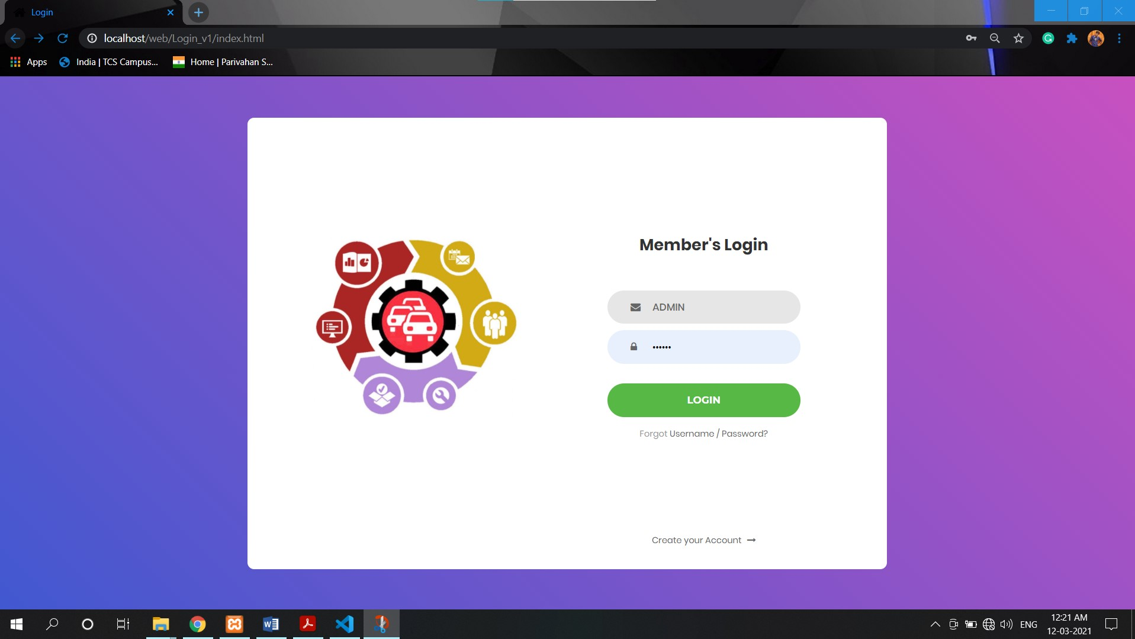

Log In Page Code:

<!DOCTYPE html>
<html lang="en">
<head>
<title>Login</title>
<meta charset="UTF-8">
<meta name="viewport" content="width=device-width, initial-scale=1">
<link rel="icon" type="image/png" href="images/icons/favicon.ico"/>
<link rel="stylesheet" type="text/css" href="vendor/bootstrap/css/bootstrap.min.css">
<link rel="stylesheet" type="text/css" href="fonts/font-awesome-4.7.0/css/font-awesome.min.css">
<link rel="stylesheet" type="text/css" href="vendor/animate/animate.css">
<link rel="stylesheet" type="text/css" href="vendor/css-hamburgers/hamburgers.min.css">
<link rel="stylesheet" type="text/css" href="vendor/select2/select2.min.css">
<link rel="stylesheet" type="text/css" href="css/util.css">
<link rel="stylesheet" type="text/css" href="css/main.css">
</head>
<body>
<div class="limiter">
<div class="container-login100">
<div class="wrap-login100">
<div class="login100-pic js-tilt" data-tilt>
<img src="images/img-01.png" alt="IMG">
</div>
<form class="login100-form validate-form">
<span class="login100-form-title">
Member Login
</span>
<div class="wrap-input100 validate-input" data-validate = "Valid email is required: ex@abc.xyz">
<input class="input100" type="text" name="email" placeholder="Email">
<span class="focus-input100"></span>
<span class="symbol-input100">
<i class="fa fa-envelope" aria-hidden="true"></i>
</span>
</div>
<div class="wrap-input100 validate-input" data-validate = "Password is required">
<input class="input100" type="password" name="pass" placeholder="Password">
<span class="focus-input100"></span>
<span class="symbol-input100">
<i class="fa fa-lock" aria-hidden="true"></i>
</span>
</div>
<div class="container-login100-form-btn">
<button class="login100-form-btn">
Login
</button>
</div>
<div class="text-center p-t-12">
<span class="txt1">
Forgot
</span>
<a class="txt2" href="#">
Username / Password?
</a>
</div>
<div class="text-center p-t-136">
<a class="txt2" href="/web/Responsive Registration Form/index.html">
Create your Account
<i class="fa fa-long-arrow-right m-l-5" aria-hidden="true"></i>
</a>
</div>
</form>
</div>
</div>
</div>
<script src="vendor/jquery/jquery-3.2.1.min.js"></script>
<script src="vendor/bootstrap/js/popper.js"></script>
<script src="vendor/bootstrap/js/bootstrap.min.js"></script>
<script src="vendor/select2/select2.min.js"></script>
<script src="vendor/tilt/tilt.jquery.min.js"></script>
<script >
$('.js-tilt').tilt({
scale: 1.1
})
</script>
<script src="js/main.js"></script>
</body>
</html>

PHP Database Code (Log In):

<?php
$link = mysqli_connect('localhost', 'root', '', 'test');
if (isset($_POST['registration'])) {
$email = $_POST['email'];
$password = $_POST['password'];
$query = $connection->prepare("SELECT * FROM registration WHERE email=:?");
$query->bindParam("email", $email, PDO::PARAM_STR);
$query->execute();
$result = $query->fetch(PDO::FETCH_ASSOC);
if (!$result) {
echo '<p class="error">Email & password combination is wrong!</p>';
} else {
if (password_verify($password, $result['password'])) {
$_SESSION['email'] = $result['email'];
echo '<p class="success">Congratulations, you are logged in!</p>';
} else {
echo '<p class="error">Username password combination is wrong!</p>';
}
}
}
?>

DATABASE DETAILS:

REGISTRATION DETAILS:

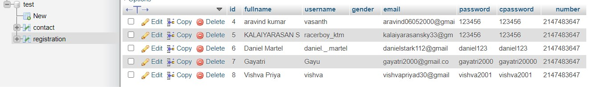

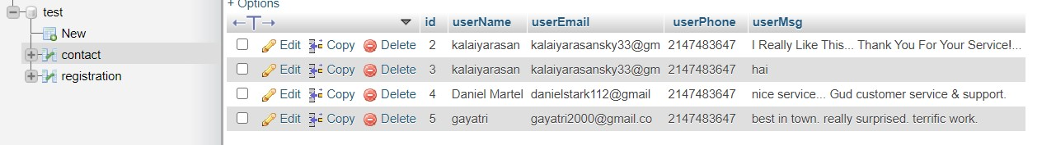
FEEDBACK DETAILS:

